**NEW TT EXPLORATORY TESTING & UI/UX IMPROVEMENTS**

* The ones highlighted are **functionally** **critical/important to fix or improve for UX**.

1. **Global**
   1. Date pickers allow writing on the but the behave so randomly (allow to write a 6-digit year for example, or jump between month & day while writing) -> Should be not allowed to write, only pick?
   2. Date pickers format is in American (mm/dd/yyyy), not European. Could confuse users.
   3. Search inputs do not allow to do a "show all results" search when pressing down key.
2. **Login**
   1. Admin: KO. Should login into the Time Tracking page.
   2. Admin-Mgr: OK. User Info
   3. Mgr: OK. User Info
   4. User: KO. Should login into the Time Tracking page.
   5. Right after login when user info is loading there appear "- - (Unknown)". Maybe put some placeholders in the hyphen’s positions instead of empty? or loader until all data is displayable?
3. **Header**
   1. Help link always redirect to user guide for "Users", it is not role-related to the logged user.
   2. The selected tab (page) is not clickable, maybe some users use it to refresh the same page they were on quickly instead of F5 or browser refresh?
   3. The Zurich logo should be clickable and redirect to the corresponding LANDING home page DEPENDING on user's role.
4. **Admin**
   1. **GENERAL**

3.1.1 Modals and dialogs allow 3 ways of closing them: Cancel button, Close (cross) icon, click outside of it.

1. Modals "ok" button is always "Submit": Should be create/modify or whatever call to action depending on the action?
   1. **PROJECT**

3.2.1 Field Cost Centre (British, the one in demo) or Cost Center (American, the one in legacy)? Should be consistent with back-end attributes of the model and column name in MySQL DB to prevent confusion for front-end developers.

* 1. **TASK**
     1. Create/Modify Task "Choose project" field is always in red when opening the modal
  2. **REPORTS**
     1. Personal Report: Selecting day of month instead of the entire month, how does this work in the background? Does it parse it and ignores the day of month the date somehow?
     2. Generate Total Report: (Same) & also not working. Is not implemented?
     3. Active Deputy Assignments Report: Giving generation error.
  3. **OPERATIONS**
     1. Reminder Email: Dialog message "Are you sure you want to send the reminding mail" -> REMINDING or reminder?
     2. Month Closure: Only allow to update current year's months. Anti-intuitive? What happens if we click "Update" on past or future year? What happens if we have just started a new year but want to close past year’s December month?

1. **User Info**
   1. Edit teams’ users with some allocation set, does not load allocation rows for the projects they are assigned to.
   2. Assign deputy: You shouldn't be able to assign yourself
   3. Assign deputy: Allow to select end date before the start date.
   4. Input ratio filter utility? If there are a lot, different, and even decimal ratios, what's the point of filtering (grouping) them?
   5. Adding people to the team, when introducing wrong or incomplete allocation information and saving, the error popup shows up, which is good, but after you close it, the add people modal closes as well, losing all introduced information and making that the user has to begin from scratch. This can be specially annoying for managers with a lot of people to manage and many projects and allocation to configure for everyone.
2. **Time Tracking**
   1. **WEEKLY VIEWS (Record Time & Approver per Month)**
      1. User selection (as a manager) is a text input field instead of a dropdown of the users of the manager's team. Besides that, seems that changing it does nothing.
      2. "New Line" is not clear enough, should be "Add new project" or "Add register" maybe, to not confuse the user like they were saving something in real time.
      3. New Line modal buttons (Create/Cancel) are not positioned as the others, they are extremely close to the modal borders.
      4. New Line project selection dropdown width is too low for long program + project names. This would be better if at least there was a separator between the items of the dropdown list.

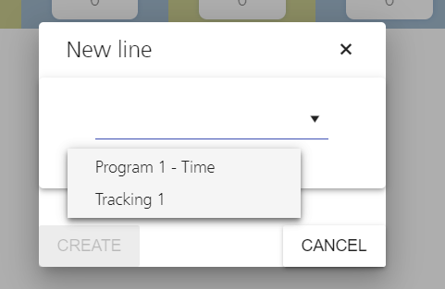

* + 1. New Line project selection after having selected one project, marks the selected project in red, which seems like something like an error or warning has triggered. That is aggressive for the user.

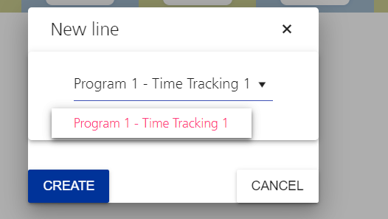

* + 1. New Line "Create" button gives the user the impression they are creating something (in the DB), but they are not until they hit Save for all the registers, not that specific line. So that is confusing.
    2. Project line has a color change animation on hover, but it's just an informative box, not an interactive one, should be animated?
    3. Project line tooltip transparency overlays with text on the week table. May be turning it solid would be better.
    4. Delete Line modal includes a dropdown input (even though it's disabled) and the same UI/UX issues that the New Line modal has.
    5. No records available box has a color change animation on hover, but it's actually just an informative box, not an a interactive one, should be animated?
    6. Comments text area size is too little to write and clearly read the messages.
    7. Hours inputs do not increase/decrease using keyboard arrows.
    8. Hours inputs have strange random behavior when using Tab to change from input to input.
    9. Hours inputs allow negative hours and furthermore, the registers can be saved but the registered hours seem to be 0 for that day.
       1. Right after saving negative values, the Monthly view (Approve or Summary) shows random input on Saturday & Sunday

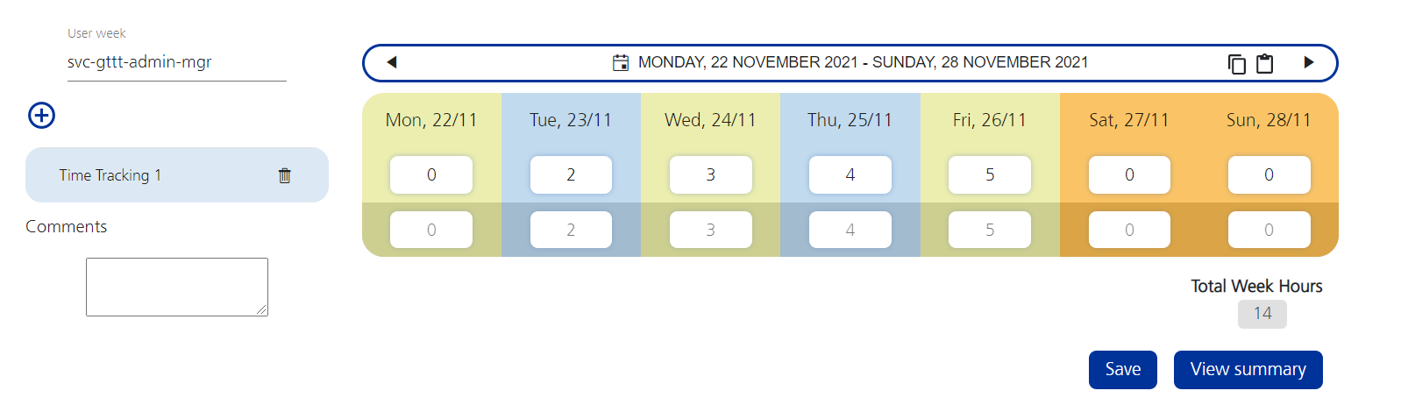

Above the saved hours after inputting **-50h** on Monday (the app saved 0h).

Below the saved hours on approve per month with the random hours on the weekend.

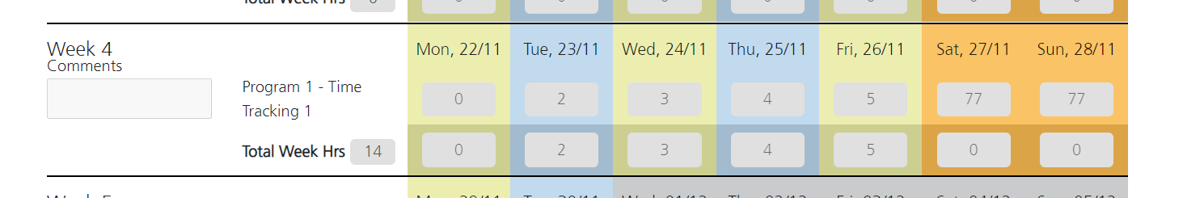

* 1. **MONTHLY VIEWS (Approve per Month & Monthly Summary)**
     1. User selection (as a manager) is a text input field instead of a dropdown of the users of the manager's team. Besides that, seems that changing it does nothing.
     2. Comment’s title and box are so close vertically to Week title.
     3. Calendar month picker does not allow to move from current year doing a scroll in the monthly calendar picker section. This should be synched with the years scroll on the left of the picker so if the user scrolls from the monthly picker, the year picker moves along.
     4. Calendar month header have a normal text cursor (like in a text editor), instead of a pointer cursor, which would indicate the user that the text is clickable and would open the month picker, as it is with the calendar button on the right.